BUTTON

The median viaduct consolidated the moieties of the resplendent Atlantis;

Thalassic tremors debilitated the bridge before its nonchalant grandees,

The augmenting vice and diminishing warmth buttressed the volcanic seamounts,

They torpedoed the straddling nexus, smashing and strewing Atlantis all about.

Sewn on the fringes of a sark are the glimmering, discoid buttons of hope,

Which amalgamate the two disparate and ever-repulsive fragments of a cope.

Their intricate threads provide them with a firm footing on the flaxen fabric;

Which once snapped dismantle the buttons and the shirt seems otiose in a flick.

Be it a toggle sewn on an attire; or the strategic isthmus of Poseidon’s empire,

Or it might symbolize the intimate correspondences that allies heritages afar.

Ignorance, expectations and prejudices render these connections weak;

The frost that survives within our heorte, makes our co-existence bleak.

Like radiance overcomes murk, let endearment and ardour obsess us;

Or else the human race might face doom as termed by the rivet popper hypothesis.

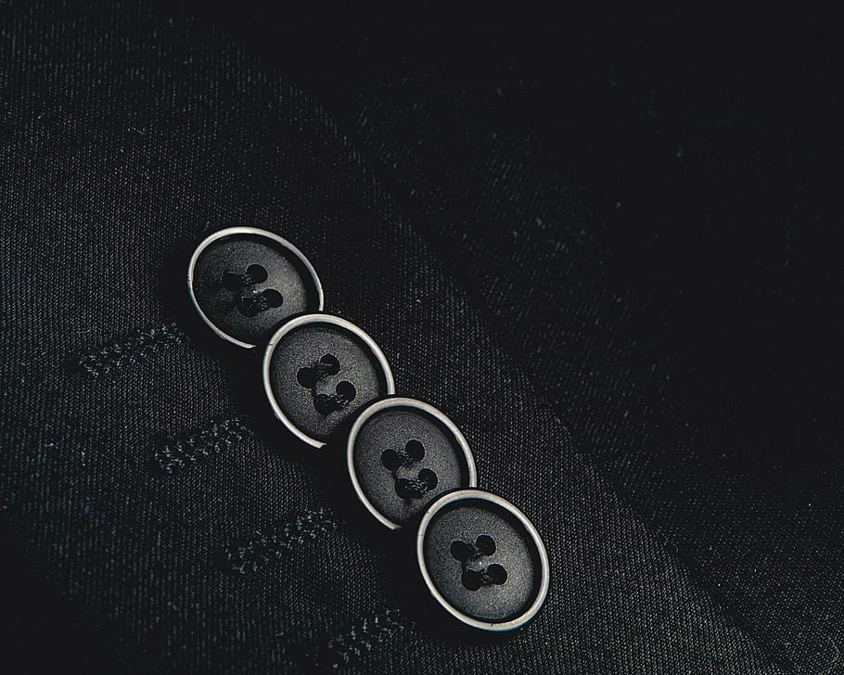

BUTTON

The median viaduct consolidated the moieties of the resplendent Atlantis;

Thalassic tremors debilitated the bridge before its nonchalant grandees,

The augmenting vice and diminishing warmth buttressed the volcanic seamounts,

They torpedoed the straddling nexus, smashing and strewing Atlantis all about.

Sewn on the fringes of a sark are the glimmering, discoid buttons of hope,

Which amalgamate the two disparate and ever-repulsive fragments of a cope.

Their intricate threads provide them with a firm footing on the flaxen fabric;

Which once snapped dismantle the buttons and the shirt seems otiose in a flick.

Be it a toggle sewn on an attire; or the strategic isthmus of Poseidon’s empire,

Or it might symbolize the intimate correspondences that allies heritages afar.

Ignorance, expectations and prejudices render these connections weak;

The frost that survives within our heorte, makes our co-existence bleak.

Like radiance overcomes murk, let endearment and ardour obsess us;

Or else the human race might face doom as termed by the rivet popper hypothesis.

-Aadityaamlan Panda